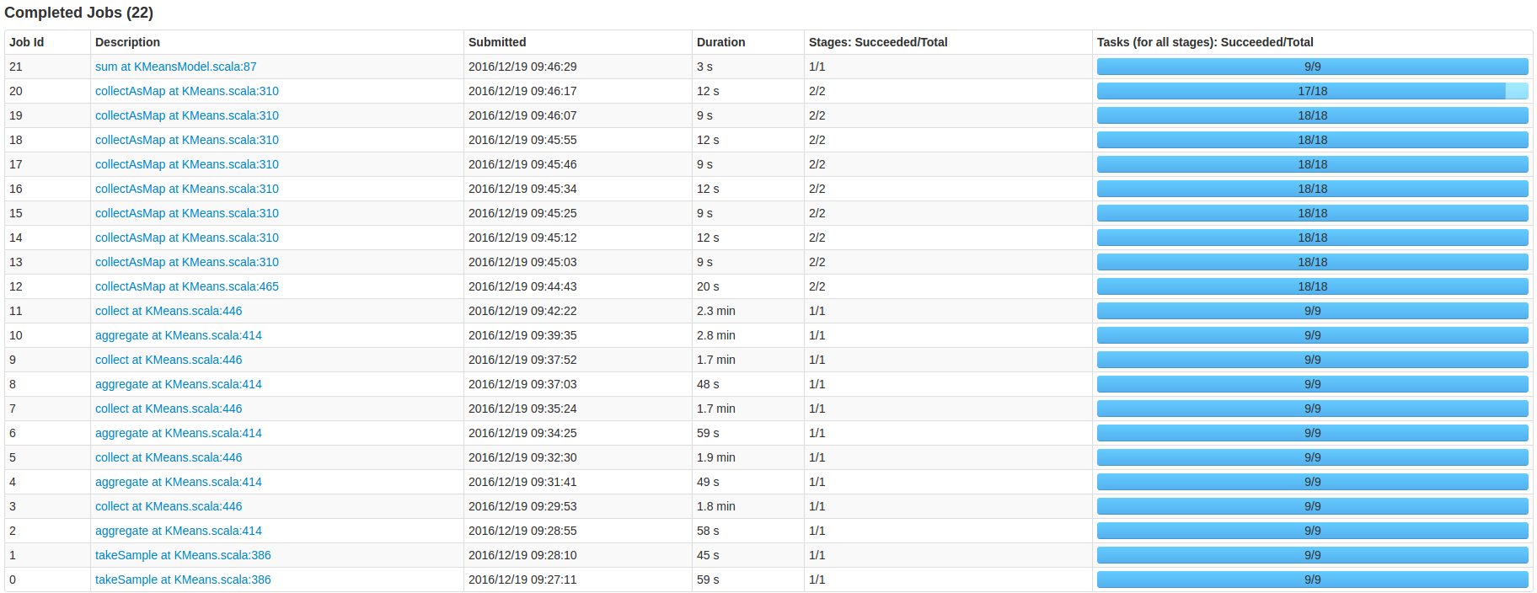

|  |  |  |
| --- | --- | --- |
| Operator | Partition | Task |
| takeSample | 9 | 9 |
| aggregate | 9 | 9 |
| collect | 9 | 9 |
| reduceByKey | 9 | 9 |
|  |  |  |

1 takeSample: task 个数等于Partition个数

2 Aggregate:task 个数等于Partition个数



3:collect:

